The chi-square goodness of fit test is used to determine if data from a sample are really distributed as they are expected to be. This test can yield valuable information regarding whether or not sample data are consistent with what is expected. It can also be used to help determine if a sample is an accurate reflection of the corresponding population.
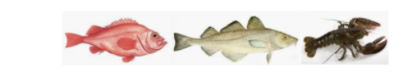

Comparing Species of Fish
For this assignment, you will use the chi-square goodness of fit test to determine if the proportion of fish species in one location is consistent with that of the surrounding area. The total fish population in the larger area is known to be equal (remember, this means equal expected proportions). Using the attached dataset, conduct a chi-square goodness of fit test with SPSS. Then create a report in which you address the following:
- Present your chi-square goodness of fit test findings.
- Interpret these findings in relation to this example. Explain whether the sample exhibits an equal distribution or not, and how you know. Be sure to include p-value.
- Describe another example of a situation in which the chi-square goodness of fit test could be helpful.
Dataset: Types of Fish
Be sure to include supporting detail from the readings, as well as other scholarly sources.
